https://gitlab.tcsbank.ru/das/openscap
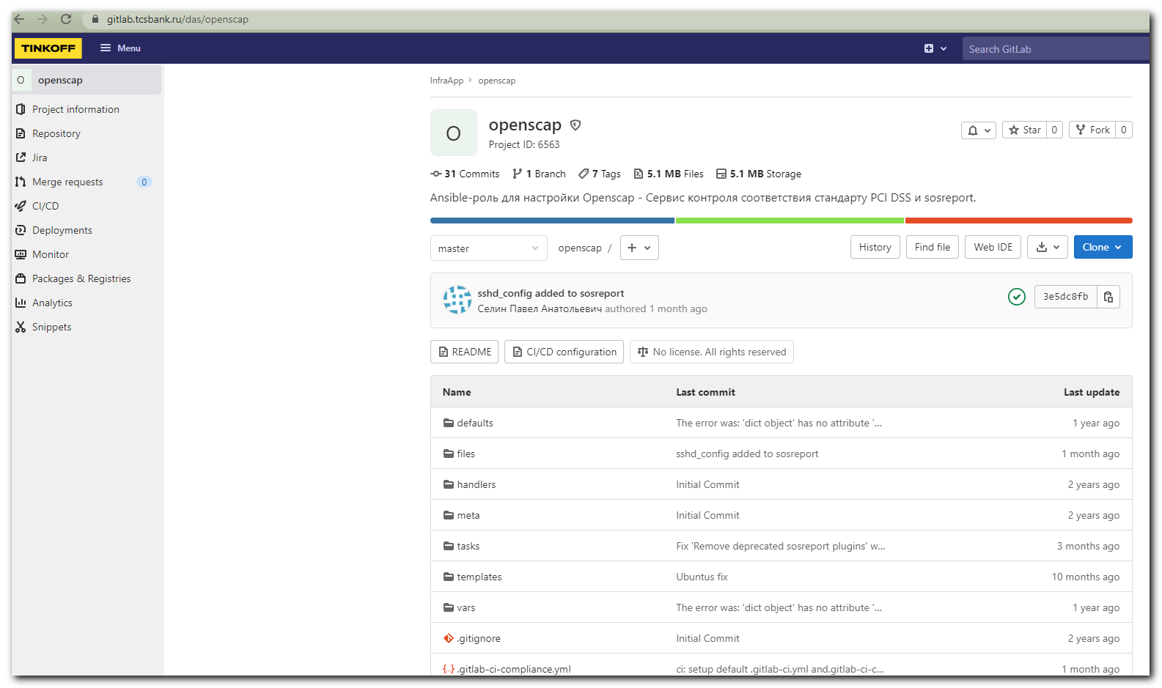

[s.belogrud@nb2339]# git clone ssh://git@gitlab.tcsbank.ru:7999/das/openscap.git

Клонирование в «openscap»…
stty: standard input: Inappropriate ioctl for device
remote: Enumerating objects: 157, done.
remote: Total 157 (delta 0), reused 0 (delta 0), pack-reused 157
Получение объектов: 100% (157/157), 4.78 MiB | 5.71 MiB/s, готово.
Определение изменений: 100% (78/78), готово.
Распаковка файлов: 100% (33/33), готово.
[s.belogrud@nb2339]#

[s.belogrud@nb2339]# ls -Alh
total 2
drwxr-xr-x 1 s.belogr UsersGrp 0 Sep 6 16:30 openscap
[s.belogrud@nb2339]# mv openscap/* ./
[s.belogrud@nb2339]# ls -Alh openscap/
total 4
drwxr-xr-x 1 s.belogr UsersGrp 0 Sep 6 16:30 .git
-rw-r--r-- 1 s.belogr UsersGrp 20 Sep 6 16:30 .gitignore
-rw-r--r-- 1 s.belogr UsersGrp 133 Sep 6 16:30 .gitlab-ci-compliance.yml
-rw-r--r-- 1 s.belogr UsersGrp 208 Sep 6 16:30 .gitlab-ci.yml
[s.belogrud@nb2339]# mv openscap/.git* ./
[s.belogrud@nb2339]# rmdir openscap/
[s.belogrud@nb2339]#

[s.belogrud@nb2339]# vim .git/config
[s.belogrud@nb2339]# cat .git/config
[core]
repositoryformatversion = 0
filemode = true
bare = false
logallrefupdates = true
ignorecase = true
[remote "origin"]
url = ssh://git@gitlab.tcsbank.ru:7999/das/openscap.git
fetch = +refs/heads/*:refs/remotes/origin/*
[branch "master"]
remote = origin
merge = refs/heads/master
[ssh]
identity = /home/mobaxterm/.ssh/id_rsa_s.belogrud
[s.belogrud@nb2339]#

#
# Here I tried to reduce annoys from stucking output. But it still not the same as option --no-pager in command line.
#
[s.belogrud@nb2339]# git config --replace-all core.pager 'less -+F -+X'
[s.belogrud@nb2339]# cat .git/config
[core]
repositoryformatversion = 0
filemode = true
bare = false
logallrefupdates = true
ignorecase = true
pager = less -+F -+X
[remote "origin"]
url = ssh://git@gitlab.tcsbank.ru:7999/das/openscap.git
fetch = +refs/heads/*:refs/remotes/origin/*
[branch "master"]
remote = origin
merge = refs/heads/master
[ssh]
identity = /home/mobaxterm/.ssh/id_rsa_s.belogrud
[s.belogrud@nb2339]#

# 20210906 Install auditd, openscap on servers ds-db28-prod2, m1-db24-dr

[support@nb2339]# export ANSIBLE_CONFIG=ansible.cfg ; logfile="$(date +%Y%m%d-%H%M).playbook.log.txt" ; ansible-playbook 20210906-1648.openscap.yml -i list_of_hosts --become --extra-vars "ansible_user=unix-ansible ansible_password=$(pass common/linux-unix-ansible) ansible_sudo_pass=$(pass common/linux-unix-ansible) ansible_ssh_common_args='-oStrictHostKeyChecking=no -oPubkeyAuthentication=no -oUserKnownHostsFile=/dev/null'" --check | tee -a ./output/${logfile}

